

Risk Profile for Mr Tony Barnes
Thomas Redmond
TFAS Wealth Ltd
11 August 2025


Risk profile
This section details how we reached an agreed risk level for this goal. It covers factors including your natural attitude to risk, capacity for loss and required return; factors used when selecting the types of investments and determining suitability.

How are risk levels used to create suitable investment portfolios?
The natural risk level, which is ascertained from the psychometric attitude to risk questionnaire score, is used as a starting point to discuss the actual level of risk you are willing and able to take to meet your specific investment objective.
In the discussion we had, you were shown a projection, based initially on your natural risk level, investment amount, target and desired time horizon. We then discussed this projection and altered any factor, including the risk level, until we agreed that the right balance had been achieved. This resulted in an agreed risk level for the investment.
To project the potential outcomes, each risk level is mapped to a collection of asset classes designed to expose you to an appropriate level of risk. Projections are produced by passing the asset class breakdown for the selected risk level to a stochastic engine that uses modelling provided by Hymans Robertson to project the future performance of the combination of asset classes.
By using these projections and discussions, we came to an agreed risk level for your specific investment objective. A portfolio will be built to meet your agreed risk level.
A summary of the results of this process is documented below.

Natural risk level
Your natural risk level is based on the answers given in the Attitude to Risk Questionnaire which was completed on 09/08/2025. The responses can be found in the appendix
Mr Tony Barnes
4  Cautious Balanced |  | As a Cautious Balanced investor you tend to see yourself as quite a cautious person and are inclined to view risk negatively rather than as a source of opportunity. If you have limited or moderate experience of investments and do not find financial matters particularly easy to understand then you may be suited to a Cautious Balanced approach to investing. You may also be suited to this approach if you take some time to make investment decisions and tend to be somewhat anxious about those decisions. As a Cautious Balanced investor you are inclined to look for safer investments, although you may consider taking some risk in exchange for increased potential returns.

Agreed risk level
Following an interactive discussion, and considering your natural attitude to risk, capacity for loss and required return for your goal, we agreed a risk level.
4  Cautious Balanced |  | As a Cautious Balanced investor you tend to see yourself as quite a cautious person and are inclined to view risk negatively rather than as a source of opportunity. If you have limited or moderate experience of investments and do not find financial matters particularly easy to understand then you may be suited to a Cautious Balanced approach to investing. You may also be suited to this approach if you take some time to make investment decisions and tend to be somewhat anxious about those decisions. As a Cautious Balanced investor you are inclined to look for safer investments, although you may consider taking some risk in exchange for increased potential returns.

No additional notes were recorded

Risk level justification
The projections for the agreed risk level are shown below. They are not intended to provide a guarantee of actual portfolio performance, rather to provide a way to illustrate how different risk levels affect the range of probable returns. Projections take account of an estimated annual total charge of 1.5% which is intended to represent tax wrapper, platform and fund charges as well as any ongoing advice charges. The actual charge will be dependent on the chosen tax wrapper, platform and fund portfolio. The projections model the effects of inflation; all figures are shown in real terms.
The details of your investment goal are as follows:
Investment Period | 5 years
Investment | £160,000
Regular Investment | £0 monthly (expressed in real terms)
Annual Increase | 4.5% per year In Addition to Inflation
You may be using more than one investment to achieve this goal. Each investment will detail the initial and any regular amount invested.
Projecting these details, along with the agreed risk level, produced the following graphs which were discussed and agreed with you:
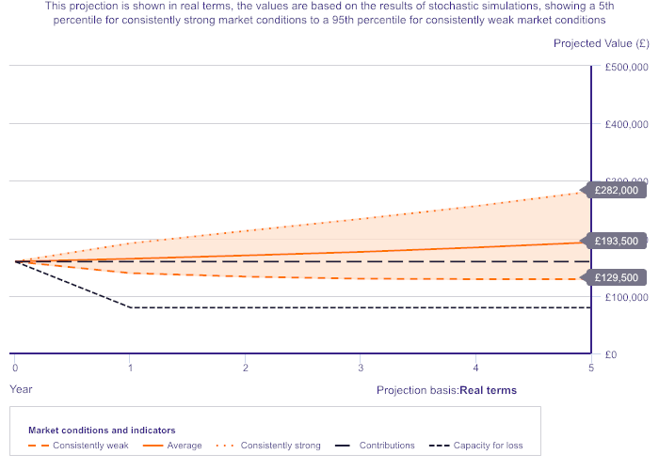
Investment Projection Graph based on Agreed Risk Level

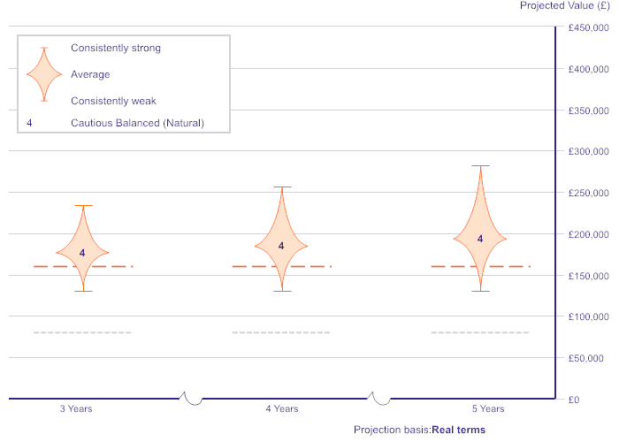
Investment Risk Comparison Graph based on Agreed Risk Level

The following areas were discussed as part of the process to agree the risk level.

Attitude to Risk
This section details any addition information related to your attitude to risk. The notes recorded following any discussions were:
Doesn’t trust anyone. Has worked long and hard for.
Client did not have time to complete an ATRQ today, so have sent him an email version to complete himself on Defaqto.
Client completed his ATRQ on 09/08/2025: outcome was ATR 4 which aligns to his mindset.

Investor Experience
This section details previous exposure and experience you have had with investments and financial markets. The notes recorded following the discussion were:
No additional notes were recorded

Capacity for loss questionnaire
This section details any addition information related to your capacity for loss which was based on the answers given in the Capacity for Loss Questionnaire. The notes recorded following any discussions were:
No additional notes were recorded

Investment target
This section details if the client is likely to achieve their desired target amount in the chosen timeframe. The notes recorded following the discussion were:
No additional notes were recorded

Agreed risk level
This section is a summary of how the risk level was agreed. These details were recorded following the discussion:
No additional notes were recorded

Capacity for loss for the goal
This section relates to your ability to absorb any losses or tolerate failure to achieve your target for this goal. These are typical risks associated with investing in the stock market. The notes recorded following the discussion were:
No additional notes were recorded

Other notes
No additional notes were recorded

Appendix

Attitude To Risk questionnaire responses for Mr Tony Barnes on 09/08/2025
Question | Response
I would describe my investment approach as: | Balanced
If you invested £20,000 and the value fell temporarily, how much of a fall, over a 12 month period, would make you feel anxious or uncomfortable? | More than £2,500
I associate the phrase 'investment risk' with the idea of: | Caution
To see a respectable gain on my investment, I am: | Happy to take some risk with a percentage of my assets
Compared to other people, I would describe myself as: | Equally cautious
In seeking a return on my investment, in the short-term I’m willing to accept: | A slight risk of capital loss
If I thought there was a possibility of my investment losing money, I would: | Understand and accept that investments can fluctuate in value
Compared to other people, I believe the following statement best fits my understanding of investment: | I have a basic understanding of what investments are but limited knowledge on how they work
If you invested £20,000 and the value fell by £3,000 over the course of a 12 month period, would you: | Be concerned and contact your adviser for an explanation
Taking risks when making investments: | Doesn't excite me
When investing money to meet my objectives I would prefer to use: | Low risk investments
I understand that, in order for my investments to keep pace with inflation, I need to take some investment risk | Agree

Investor Experience questionnaire responses for Mr Tony Barnes on 09/08/2025
Question | Response
When it comes to your experience and understanding of investing, how would you describe yourself? | Very little understanding / knowledge
Do you understand how Current Accounts, Savings/Deposit Accounts, Cash ISA, National Savings and Investments work and do you know the risks associated with them? | A fair degree of understanding / knowledge
Do you understand how Unit Trusts and General Investment Accounts work and do you know the risks associated with them? | No understanding / knowledge
Do you understand how stocks and shares work and do you know the risks associated with them? | No understanding / knowledge
Do you understand how Enterprise Investment Schemes and Venture Capital Trusts work and do you know the risks associated with them? | No understanding / knowledge
Do you understand how pension planning and income in retirement works and do you know the risks associated with them? | Very little understanding / knowledge
Have you invested in Current Accounts, Savings/Deposit Accounts, Cash ISA, National Savings and Investments within the last 5 years? | Yes, by myself
Have you invested in Unit Trusts and General Investment Accounts within the last 5 years? | No
Have you invested in stocks and shares within the last 5 years? | Yes, by myself
Have you invested in Enterprise Investment Schemes and Venture Capital Trusts within the last 5 years? | No
Have you invested in pension planning and income in retirement products within the last 5 years? | Yes, through a financial adviser
Do you check the valuation of your investment and retirement portfolio on an annual basis? | Yes, by myself

Capacity For Loss questionnaire responses for Mr Tony Barnes on 09/08/2025
Question | Response
I am investing in order to meet goals at what point in the future (my investment horizon). | 3-9 years
I have or expect to incur significant outstanding debts during the period of my investment (e.g., mortgage or credit cards). | Strongly disagree
My spouse or partner (or another family member) is likely to be able and willing to support me financially if circumstances require. | Strongly disagree
It would be relatively easy for me to cut my spending in retirement if circumstances require. | Disagree
I am flexible about my retirement date (or other determinant of investment horizon). | Agree

